# PRACTICE 1

Determine:

1. The most disadvantaged consumer
2. Total head at the reservoir for the average flow regime
3. Total head at the reservoir for the maximum flow regime
4. Mapa de colores

   Descripción generada automáticamente con confianza mediaThe most disadvantaged consumer is consumer H, with a negative pressure of -21.87
5. Total head for the average flow is 21.88

1. 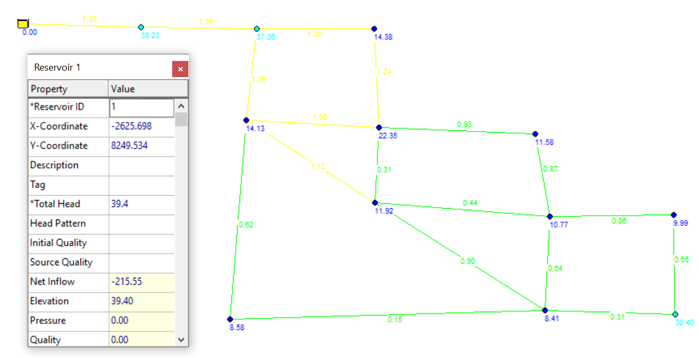Total Head for the maximum flow regime is in 39.4